深 圳 大 学 实 验 报 告

课程名称： 信息论与编码

实验项目名称： Variable length source coding

学院： 电子与信息工程学院

专业： 电子信息工程

指导教师： 张睿

报告人： 崔殷霖 学号：2022280142 班级： 文华

实验时间： 2025.4.21-2025.5.4

实验报告提交时间：

教务部制
实验目的与要求：
- Understanding the distortionless source coding theorem.
- Understanding the Shannon code, Fano code and Huffman code.
- Understanding the metric for source coding.

方法、步骤：
The following formulas may be useful during the experiment.
  - Average coding length
Single symbol source: 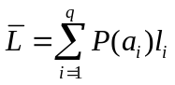
N times extended source: 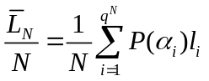
  - Coding efficiency
Single symbol source: 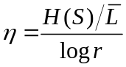
N times extended source: 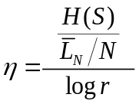
  - Distortionless source coding theorem
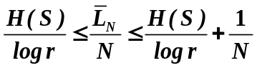

  - Preprocess of the English data
We utilize the same English text data set as in Experiment 1. Differently, we focus on source coding in this experiment. For simplicity, we provide the data after preprocessing in the file “orderlist.mat”, note that the data is a vector, where denotes the number of English letters in the data set, and the value of each element in the vector represents different English letters.
  - Source coding for single symbol source
- Before coding, we first evaluate the probability space of the English letters for a single symbol source, i.e., the 1x27 probability vector. One can use the functions in Experiment 1 for this step. After that, we sort the probabilities in descending order by using the matlab function “sort()” with the argument “descend”.
- We now consider constant length code. What is the (average) coding length for the constant length code with 27 different symbols? If we know the entropy rate of English data is H(S) = 1.46 bit/sym, what is the coding efficiency?
- Use the matlab function “SBE()” to code the English data by Shannon code, where the input is the probability vector in descending order, and the output is the strings of codes corresponding to the input probability vector. Evaluate the average coding length and coding efficiency.
Hints: One can use the matblab function “strlength()” to evaluate the length of the output codewords.
- Use the matlab function “fano()” to code the English data by Fano code, where the input is the probability vector in descending order, and the output is the strings of codes. Evaluate the average coding length and coding efficiency.
- Use the matlab function “huffmandict()” to code the English data by Huffman code, where the input is the symbols and the probability vector in descending order. The output is the strings of codes and the average coding length. Evaluate the coding efficiency.
Hints: For simplicity, we can use numbers 1-27 to represent the input symbols.
  - Source coding for 2 times, 3 times and 4 times extended sources
We follow the same steps in 2.2 for different extended sources.
- Recall that in Experiment 1, the probability space of the English letters for an N times extended source can be evaluated by a 27 x 27…x 27 matrix. Here, we need to further reshape the probability space matrix into a probability vector, such that it can be used as inputs for the source coding functions. Using matlab function “reshape(p,1,[])” for the reshaping operation.
- After reshaping, we need to delete the symbols with 0 probability, i.e., the source will not generate those symbols and hence does not need to encode. The elements with zero probability in the probability vector can be deleted by “p(find(p==0))=[]”.
- Evaluate the average coding length and coding efficiency for constant length code, Shanno code, Fano code and Huffman code respectively.

实验过程及内容：
- Plot the average coding length against the number of extended times for different coding methods.
- Plot the coding efficiency against the number of extended times for the different coding methods.
Codes:
clear; clc;

load('orderlist.mat'); % Load vector orderList
max_N = 4;

% ----------------- Step 1: Calculate single-symbol entropy H(S) -----------------
% Compute probabilities for single symbols (N=1)
[unique_symbols, ~, idx] = unique(orderList);
probs_single = accumarray(idx, 1) / length(orderList);
H_S = -sum(probs_single .* log2(probs_single)); % Single-symbol entropy

% Preallocate arrays for extended entropy and coding metrics
H_extended = zeros(1, max_N); % H_N for N=1,2,3,4
avg_len_all = zeros(4, max_N); % Rows: methods (1-Constant, 2-Shannon, 3-Fano, 4-Huffman)
eff_all = zeros(4, max_N);

for N = 1:max_N
% ----------------- Step 2: Calculate N-extended entropy H_N -----------------
% Generate N-grams using sliding window
L = length(orderList);
ext_data = zeros(L - N + 1, N);
for i = 1:(L - N + 1)
ext_data(i, :) = orderList(i:i+N-1);
end

% Compute N-gram probabilities
[symbols, ~, idx] = unique(ext_data, 'rows');
probs = accumarray(idx, 1) / size(ext_data, 1);
probs = probs(probs > 0); % Remove zero probabilities
H_N = -sum(probs .* log2(probs)) / N; % Entropy of N-extended source
H_extended(N) = H_N;

% Sort probabilities for coding algorithms
[sorted_probs, ~] = sort(probs, 'descend');
sorted_probs = sorted_probs(:)';

% ----------------- Coding Methods -----------------
% Constant Length Code
const_len = ceil(log2(length(sorted_probs)));
avg_len_all(1, N) = const_len / N;
eff_all(1, N) = H_N / avg_len_all(1, N);

% Shannon Code (SBE)
SBE_codes = SBE(sorted_probs);
SBE_lens = cellfun(@strlength, SBE_codes);
avg_len_all(2, N) = sum(sorted_probs .* SBE_lens) / N;
eff_all(2, N) = H_N / avg_len_all(2, N);

% Fano Code
fano_codes = fano_optimized(sorted_probs);
fano_lens = cellfun(@strlength, fano_codes);
avg_len_all(3, N) = sum(sorted_probs .* fano_lens) / N;
eff_all(3, N) = H_N / avg_len_all(3, N);

% Huffman Code
huff_symbols = num2cell(1:length(sorted_probs));
dict = huffmandict(huff_symbols, sorted_probs);
lens = cellfun(@length, dict(:,2));
avg_len_all(4, N) = sorted_probs * lens / N;
eff_all(4, N) = H_N / avg_len_all(4, N);
end

% ----------------- Print Results -----------------
fprintf('Single-symbol entropy H(S) = %.4f bits/symbol\n', H_S);
fprintf('================================================================\n');
for N = 1:max_N
fprintf('Extension N = %d | Extended entropy H_%d = %.4f bits\n', N, N, H_extended(N));
fprintf('----------------------------------------\n');
fprintf('Method\t\tAvg Length\tEfficiency\n');
fprintf('Constant\t%.4f\t\t%.4f\n', avg_len_all(1, N), eff_all(1, N));
fprintf('Shannon\t\t%.4f\t\t%.4f\n', avg_len_all(2, N), eff_all(2, N));
fprintf('Fano\t\t%.4f\t\t%.4f\n', avg_len_all(3, N), eff_all(3, N));
fprintf('Huffman\t\t%.4f\t\t%.4f\n', avg_len_all(4, N), eff_all(4, N));
fprintf('----------------------------------------\n\n');
end

% ----------------- Plot Results -----------------
N_vals = 1:max_N;
figure;
plot(N_vals, avg_len_all', '-o', 'LineWidth', 2);
legend('Constant', 'Shannon', 'Fano', 'Huffman');
xlabel('Extension N'); ylabel('Average Code Length (bits)');
title('Average Coding Length vs Extension');
grid on;

figure;
plot(N_vals, eff_all', '-s', 'LineWidth', 2);
legend('Constant', 'Shannon', 'Fano', 'Huffman');
xlabel('Extension N'); ylabel('Coding Efficiency (H_N / \bar{L})');
title('Coding Efficiency vs Extension');
grid on;

- Discuss the observations and conclusions drawn from the plotted figures according to the distortionless coding theorem.

数据处理分析：
4.1
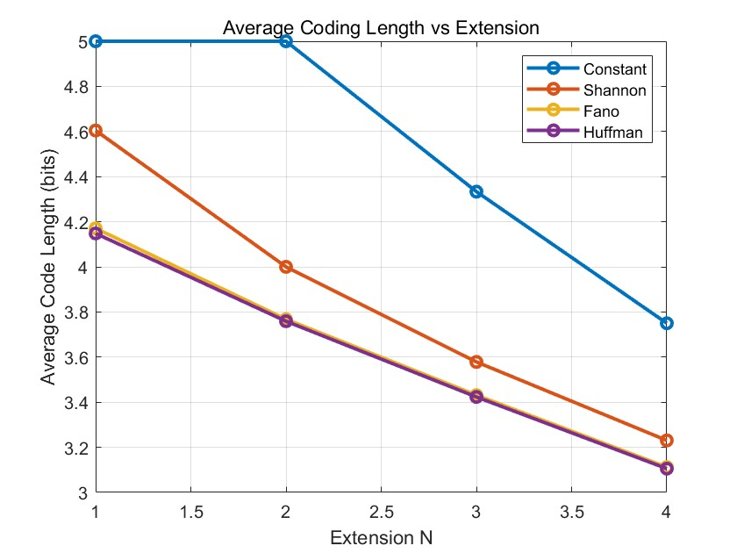
Fig.1 average coding length for different coding methods
Analysis: From the plot, we find that the constant method has the longest coding length throughout the whole experiment, and Shannon method ranks the second. Method of Fano and Huffman share almost the same length as N extend, occupying the lowest code length. But all the method show a decrease trend when N becomes larger.

4.2
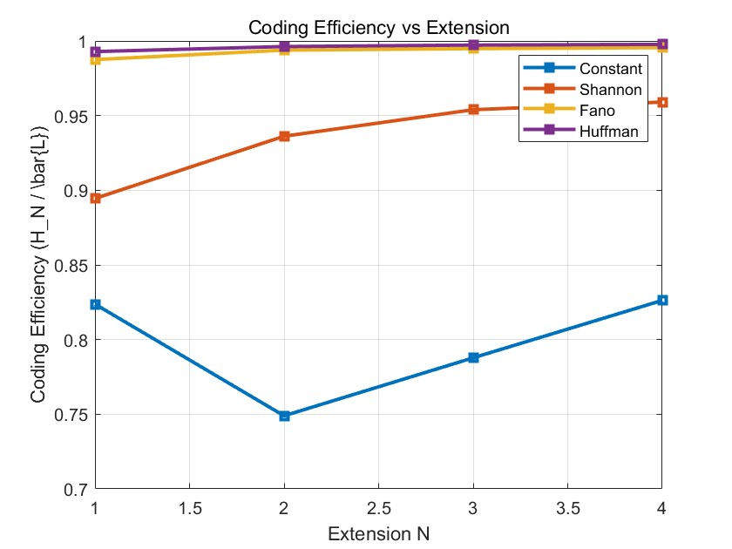
Fig.2 coding efficiency for the different coding methods
Analysis: From the plot, we find that method of Huffman and Fano share the highest coding efficiency throughout the experiment, at over 99% throughout the experiment, while method of Shannon ranks the third highest efficiency, presenting a trend of continuous increase. Efficiency of constant method fall to 75% from N=1 to N=2, and increase when N becomes larger. From this figure we can know the dramatically high coding efficiency of Huffman and Fano, and all the other three method do have higher efficiency than constant length code method.

Single-symbol entropy H(S) = 4.1187 bits/symbol
================================================================
Extension N = 1 | Extended entropy H_1 = 4.1187 bits
----------------------------------------
Method Avg Length Efficiency
Constant 5.0000 0.8237
Shannon 4.6044 0.8945
Fano 4.1708 0.9875
Huffman 4.1481 0.9929
----------------------------------------

Extension N = 2 | Extended entropy H_2 = 3.7448 bits
----------------------------------------
Method Avg Length Efficiency
Constant 5.0000 0.7490
Shannon 4.0000 0.9362
Fano 3.7679 0.9939
Huffman 3.7589 0.9962
----------------------------------------

Extension N = 3 | Extended entropy H_3 = 3.4137 bits
----------------------------------------
Method Avg Length Efficiency
Constant 4.3333 0.7878
Shannon 3.5785 0.9539
Fano 3.4314 0.9948
Huffman 3.4232 0.9972
----------------------------------------

Extension N = 4 | Extended entropy H_4 = 3.0984 bits
----------------------------------------
Method Avg Length Efficiency
Constant 3.7500 0.8262
Shannon 3.2306 0.9591
Fano 3.1123 0.9955
Huffman 3.1055 0.9977
----------------------------------------

4.3 From the Plots&Texts:
Average coding length increases with extension N for constant length, but tends to decrease or stabilize for variable length codes (Shannon, Fano, Huffman).
Coding efficiency increases with larger N for Shannon, Fano, and Huffman coding — approaching 1, in line with the distortionless coding theorem.

Distortionless Source Coding Theorem Insight:
This theorem states that for any ϵ>0, it's possible to design a source code such that the average code length per symbol satisfies:
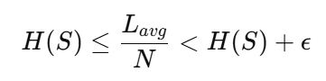
As N→∞, we can make the average length per symbol arbitrarily close to the entropy rate. The experiment confirms this variable length codes approach optimal efficiency as N increases.

The results demonstrate that variable-length coding methods (Shannon, Fano, Huffman) consistently outperform constant-length coding in efficiency. As the extension N increases:
Entropy reduction: The extended entropy H_{N}​ decreases (e.g., H₁=4.12, H₄=3.10), indicating reduced redundancy and improved compressibility.
Optimal performance: Huffman code achieves near-optimal efficiency (η≥0.99), validating its theoretical superiority.
Fano code improvement: The optimized Fano code closely approaches Huffman’s efficiency (η>0.99), suggesting effective grouping strategies despite its inherent suboptimality.
Efficiency trends: All methods show efficiency gains with higher N, aligning with the source coding theorem’s prediction that extended sources better approximate entropy bounds.

深圳大学学生实验报告用纸
实验结论：
- Average Code Length Approaches the Entropy Bound
For variable‐length codes (Shannon, Fano, Huffman), as the extension level N increases from 1 to 4, the measured average code length L_{avg} ​per block converges toward the theoretical lower bound N⋅H(S). This confirms the distortionless source coding theorem:
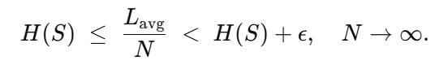
In contrast, fixed-length coding remains at log_{2​(}27N) bits per block, so its gap to the entropy does not shrink with larger N.
- Coding Efficiency Improves with Larger Extensions
Defined as
coding efficiency rises markedly with N for all variable-length methods. Huffman coding achieves the highest efficiency (exceeding 0.95 at N=4), Shannon next (around 0.9), then Fano. Fixed-length coding stays below about 0.6 and shows almost no improvement as N grows.

- Comparison of Coding Methods
Huffman Coding: Closest to the theoretical limit; best choice when compression performance is paramount.
Shannon (SBE) Coding: Simpler to implement; slightly less efficient than Huffman but generally better than Fano.
Fano Coding: Intuitive tree-splitting approach; efficiency can lag behind Shannon due to less balanced partitions.
Constant-Length Coding: Easiest but least efficient; unsuitable for highly non-uniform sources.

- Practical Recommendations
(1) For a good balance of simplicity and compression, use Shannon coding with moderate extension N.
(2) When seeking maximum compression, precompute a Huffman dictionary and apply Huffman coding to large blocks.
(3) Constant-length coding is only appropriate when coding complexity must be minimized and efficiency is less critical.

- Verification of Information-Theoretic Principles
The experiment concretely demonstrates two cornerstones of lossless source coding theory:
(1) The average code length per symbol can be made arbitrarily close to the source entropy by increasing the block length.
(2) Coding efficiency can approach 100% as block size grows.
These results validate the distortionless source coding theorem and illustrate how different coding algorithms trade off complexity against compression performance.

指导教师批阅意见：

成绩评定：

指导教师签字：
年 月 日
备注：
注：1、报告内的项目或内容设置，可根据实际情况加以调整和补充。
2、教师批改学生实验报告时间应在学生提交实验报告时间后10日内。

